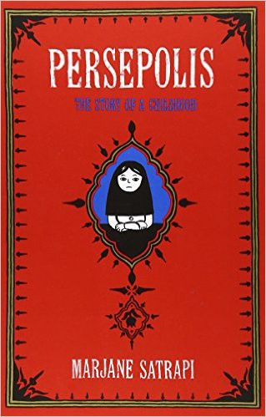

Name: Date: Period:

**Themes**

***Evidence and Analysis***

**Directions:** A theme is a concept or idea that an author explores in a literary

work. For each theme, collect 5-6 details from *Persepolis* (such as specific plot points, symbols, or quotes) that the author uses to explore that theme and enter them in the Evidence section of the table.

Next, use the evidence you’ve collected to write a Theme Description that explains the role of the theme in

*Persepolis*. Your Theme Description should be 1-2 paragraphs. Here are some questions to consider as you write each Theme Description:

•

How do the ideas or actions of the main characters reflect different aspects of the theme?

•

Does the theme develop or change over the course of Persepolis? If so, how?

•

If your evidence includes symbols, explain how the author uses those symbols to explore the theme.

•

If your evidence includes specific quotes from the text, explain how those quotes provide examples of how

the theme applies to Persepolis



Name: Date: Period:

**Religion, Repression, and Modernity**

**Theme Description**

**Evidence**

1.

2.

3.

4.

5.

6.

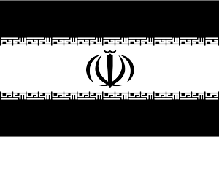

Name: Date: Period:

**Nationalism, Heroism, and Martyrdom**

**Theme Description**

**Evidence**

1.

2.

3.

4.

5.

6.



Name: Date: Period:

**Violence, Forgiveness, and Justice**

**Theme Description**

**Evidence**

1.

2.

3.

4.

5.

6.



Name: Date: Period:

**Children, War, and Growing Up**

**Theme Description**

**Evidence**

1.

2.

3.

4.

5.

6.



Name: Date: Period:

**The Personal vs. the Political**

**Theme Description**

**Evidence**

1.

2.

3.

4.

5.

6.



Name: Date: Period:

**Gender**

**Theme Description**

**Evidence**

1.

2.

3.

4.

5.

6.